**Explanation to Hooks, Actions, Filters:**

1. Filters:

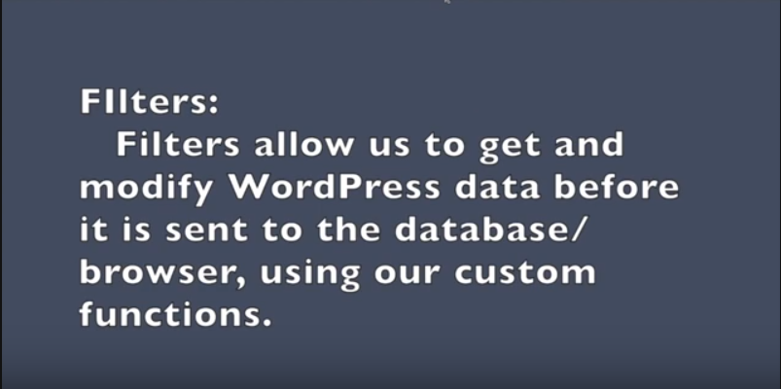

1. Difference between Actions and Filters

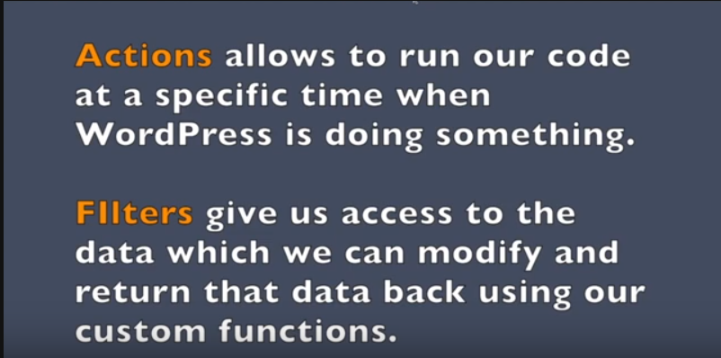

1. Actions & Filters (How to add hook or execute a hooked function)

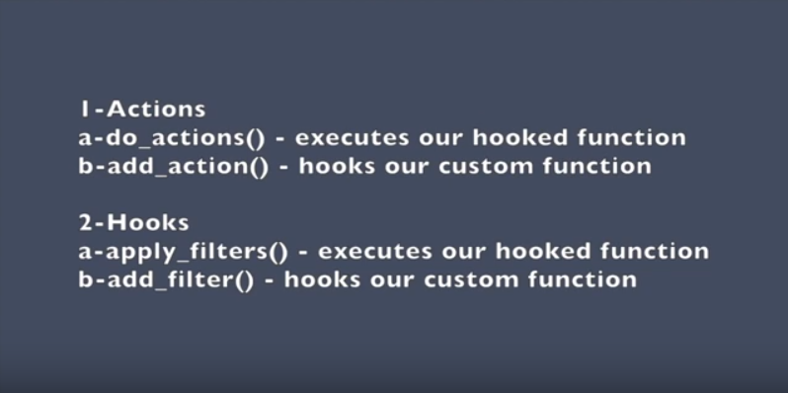

4- Do Action and Add Action:

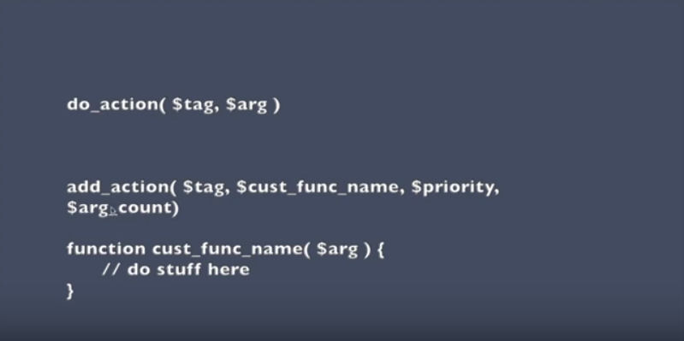

**do_action ($tag,$arg)**

* $tag is for the name of the hook.
* $arg is function arguments and you can add more than one argument in do_action function

**Add_action($tag,$cust_func_name,$priority,$arg_count)**

* $tag is for the name of the hook (String)
* $cust_func_name is for the name of the function (String)
* $priority this indicates the priority when you want this function to be executed
* Default is 10 (note: The lowest priority with same name of hook will be executed first)(integer)
* $arg_count indicates how many argument you are going to use in your function (integer) (default is 1)

1. Apply_Filters & Add_filter:

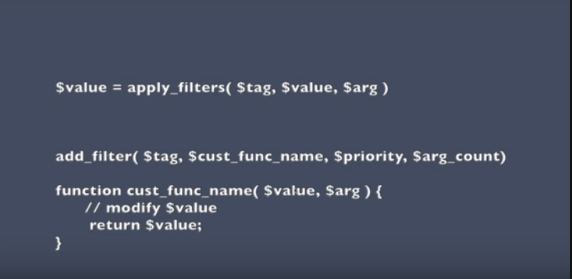

The same as Actions accept that apply_filters give us access to a $value that we can use it in our custom function.